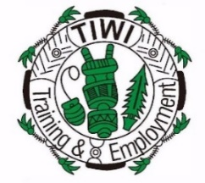
TITEB MEETING CIRCUIT
JANUARY - DECEMBER 2025
BOARD MEETINGS
TYPE | DATE | LOCATION
AI & Governance Workshop + Board Meeting | 12-13 February 2025 | Darwin
Strategic Review + Board Meeting | 16 April 2025 | Milikapiti
Board Meeting | 11 June 2025 | Pirlangimpi
Review of 2024 Strategic Plans & Strategic Planning for 2025 | 10 September 2025 | Wurrumiyanga
AGM  + Board Christmas Dinner | 28 November 2025 | Darwin
Locations will only be changed if weather conditions are unfavourable.

